ALT-F8

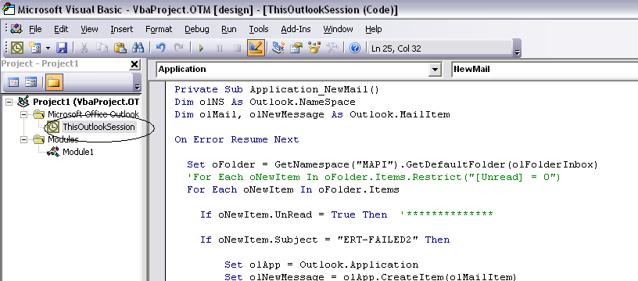

Private Sub Application_NewMail()
Dim olNS As Outlook.NameSpace
Dim olMail As Outlook.MailItem

On Error Resume Next

Set oFolder = GetNamespace("MAPI").GetDefaultFolder(olFolderInbox)
For Each oNewItem In oFolder.Items

If oNewItem.UnRead = True Then '**************

Set olApp = Outlook.Application
Set olNewMessage = olApp.CreateItem(olMailItem)

With olNewMessage
.Recipients.Add "tomdaler@yahoo.com"
.Subject = oNewItem.Subject
.Body = oNewItem.Body
.Send
End With
oNewItem.UnRead = False
End If

Next
End Sub

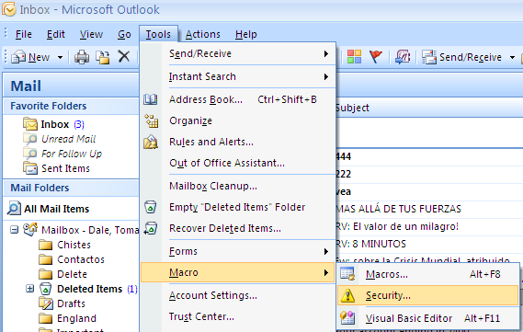

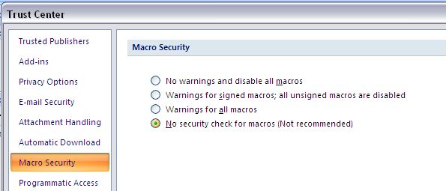

Otra opcion

